**HTML Images**

**Images In Webpage:**

The HTML ***img* *tag*** defines an image in the HTML document.

**Syntax:**



**Representation:**



**Code:**



**Output:**

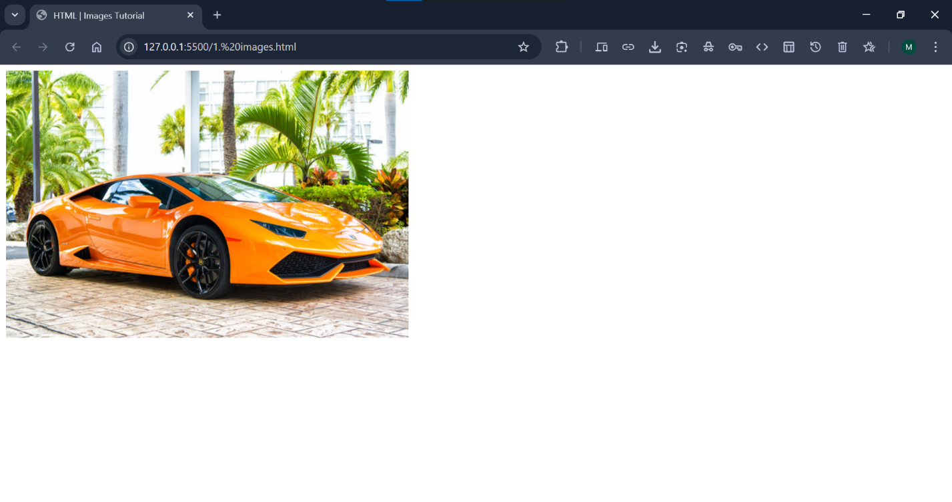

**More About <img>Tag:**

The HTML ***<img>*** tag is used to ***embed*** an image in a web page.

Images are not technically **inserted** into a web page; images are **linked** to web pages.

The <img> tag creates a holding space for the **referenced** image.

The image tag is an ***Empty Tag***. It does not have a **Closing Tag**.

The image tag is an ***Inline Element***.

***Note:*** Images can improve the design and the appearance of a web page but loading large images takes time, and can slow down your web page. Use images carefully.

**Attributes of <img> Tag:**

There are 4 attributes of img tag:

1. src
2. alt
3. height
4. width

**The src Attribute:**

The ***src*** attribute specifies the ***path (URL)*** of the image.

**Code:**



**Output:**



**More About src Attribute:**

The ***src*** is the ***required*** attribute of img tag.

If we did not specify/define/give the address/path/URL of the image, then the image will not display in the browser or in the webpage.

**Code:**

***Did not*** ***specify the path of the image:***



**Output:**

***There is no image to display in the webpage:***

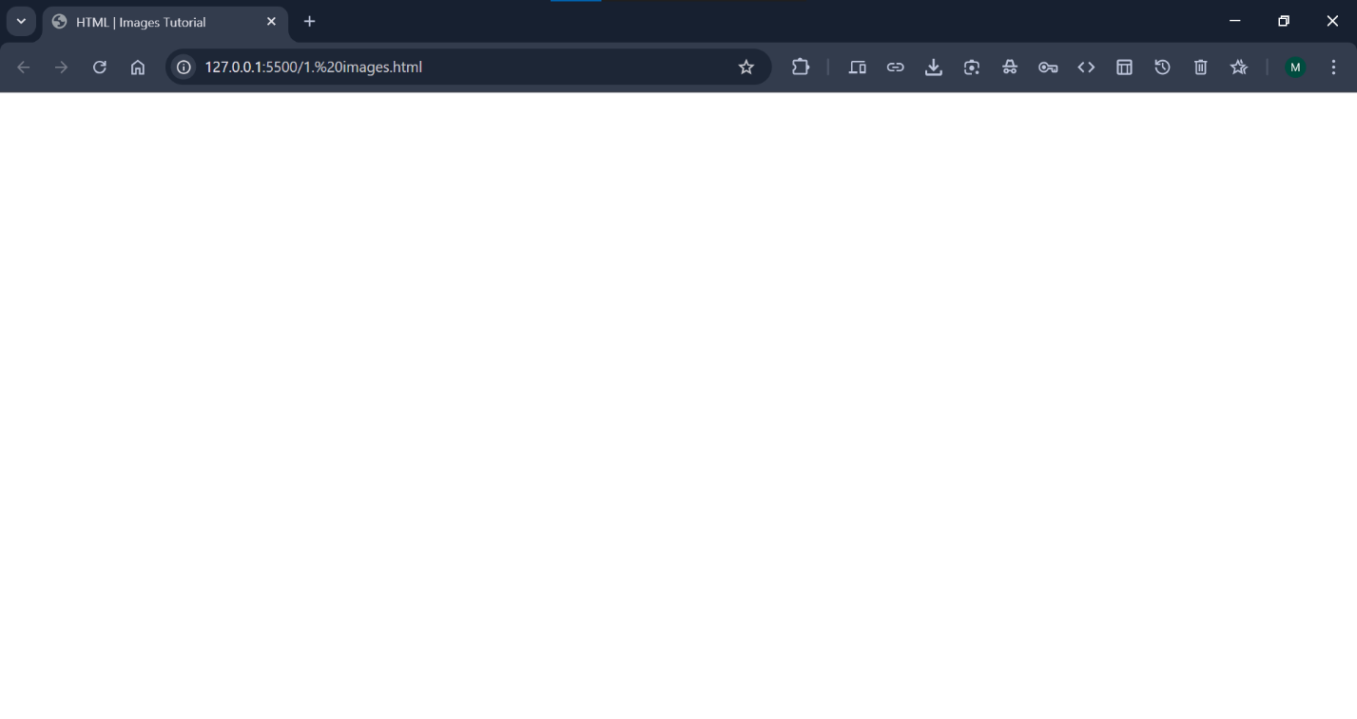

And if we give the ***wrong URL*** of the image, or the URL of the image that ***does not exist***, in this condition, image will ***not display*** in the webpage.

**Code:**

***Did not specify the path of the image:***



**Output:**

***Image will not display in the webpage:***



***Note:*** When a web page loads, it is the browser, at that moment, that gets the image from a web server and inserts it into the page. Therefore, make sure that the image actually stays in the same spot in relation to the web page, otherwise your visitors will get a broken link icon. The broken link icon and the alt text are shown if the browser cannot find the image.

**The alt Attribute:**

The ***alt*** attribute provides an ***alternate text*** for an image.

The ***alt*** attribute describes ***what the image actually is!***

So, the ***value*** of the alt attribute should ***describe the image***:

**Code:**

***Give the correct URL then only image will display, alt text will not show in the webpage:***



**Output:**



**More About alt Attribute:**

The ***alt*** is the ***required*** attribute of img tag because the value of ***alt*** attribute will display in the webpage, if the browser cannot find an image to display in the webpage or the user cannot view the image for some reason (because of slow internet connection, or an error occurs in the ***src*** attribute, or you give the wrong URL of the image or the image have been removed from the server or if the user uses a screen reader), it will display the ***value*** ***of the*** ***alt attribute***:

**Code:**

***Give the wrong URL in src attribute then alt text will show and image will not display in the webpage:***



**Output:**

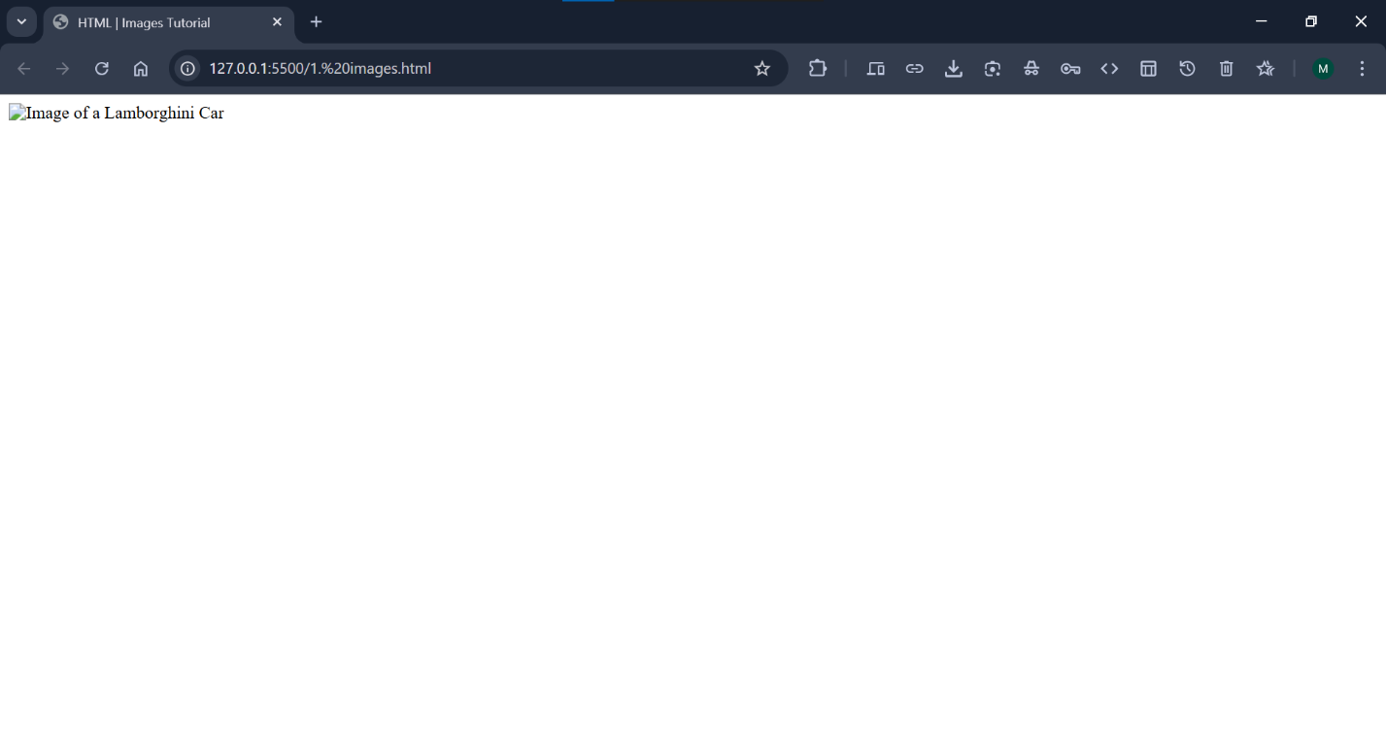

If we did not specify/define/give the address/path/URL of the image, then the image will not display in the browser or in the webpage.

**Code:**

***Do not specify the URL in src attribute then alt text will show and image will not display in the webpage:***



**Output:**



***Tip:*** A screen reader is a software program that reads the HTML code, and allows the user to "***listen***" to the content. Screen readers are useful for people who are visually impaired or learning disabled.

**The width & height Attribute:**

The width and height attribute defines the size of an image in HTML document.

**Code:**

***Specify the height of the image with* “*height*” *attribute:***



**Output:**

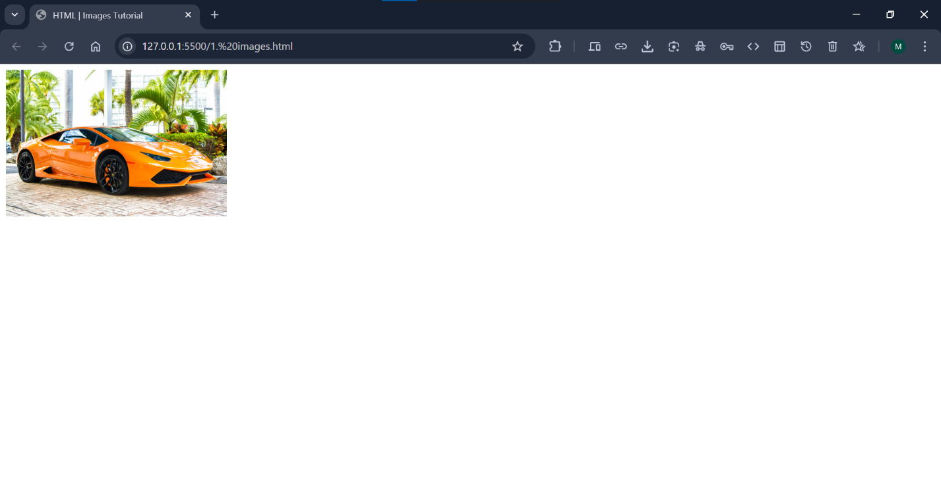

**Code:**

***Specify the width of the image with* “*width*” *attribute:***



**Output:**

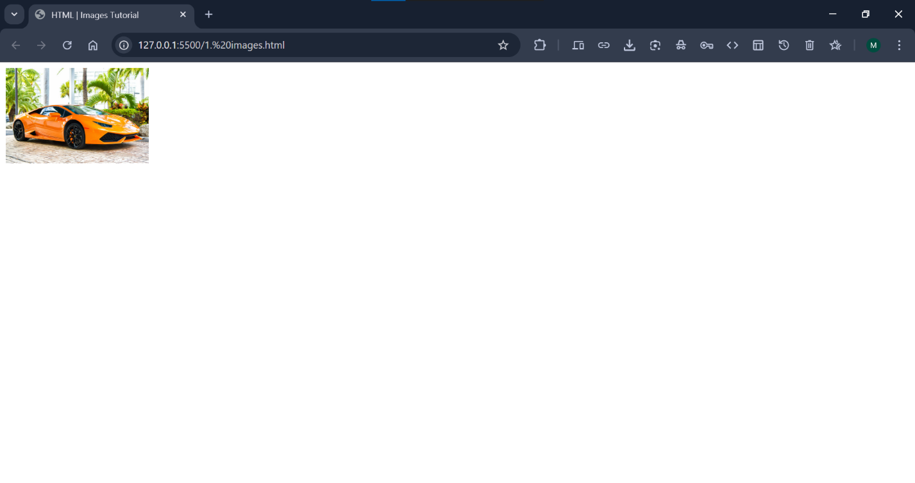

In the above code, we use only 1 attribute from height and width.

Now we will use both height and width attribute to specify the size of the image and see what happen!

**Code:**



**Output:**

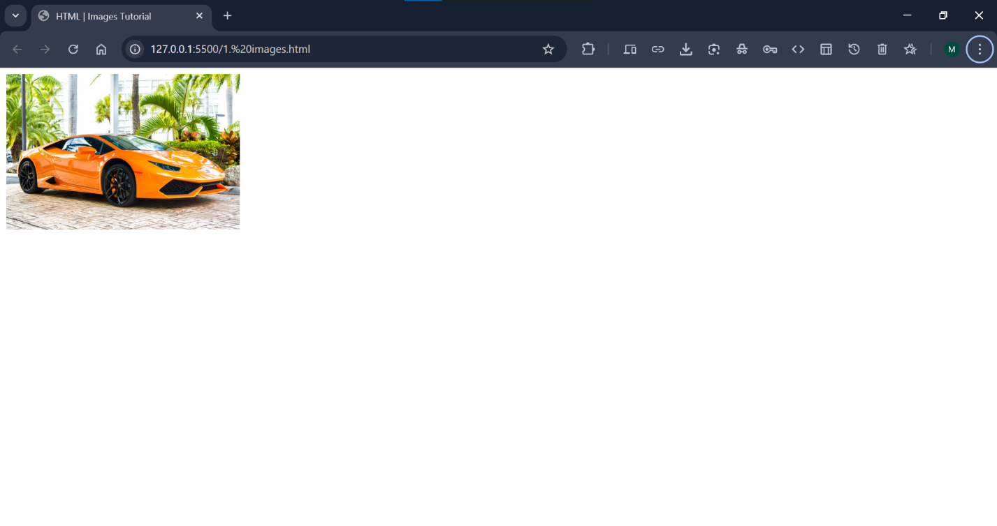

Now we can see that the aspect ratio of the image is little bit distorted.

So, it is difficult to maintain the aspect ratio of the image by using both "height" and "width" attributes in img tag. So that's it is recommended to use only 1 attribute at a time from height and width to maintain the aspect ratio of the image. Because if we use only 1 attribute from both of them then HTML or browser will automatically set the aspect ratio of the image, we don’t need to maintain it.

**More About width & height Attribute:**

The width and height attributes always define the width and height of the image in pixels.

***Note:*** Always specify the width and height of an image. If width and height are not specified, the web page might flicker while the image loads.

**Use style Attribute:**

Alternatively, we can use the ***style*** attribute instead of width and height attribute to specify the size of an image.

Style attribute can be used in 3 ways:

1. Inline CSS
2. Internal CSS
3. External CSS

**Code:**

***The following code shows only use style attribute as an inline CSS:***



**Output:**

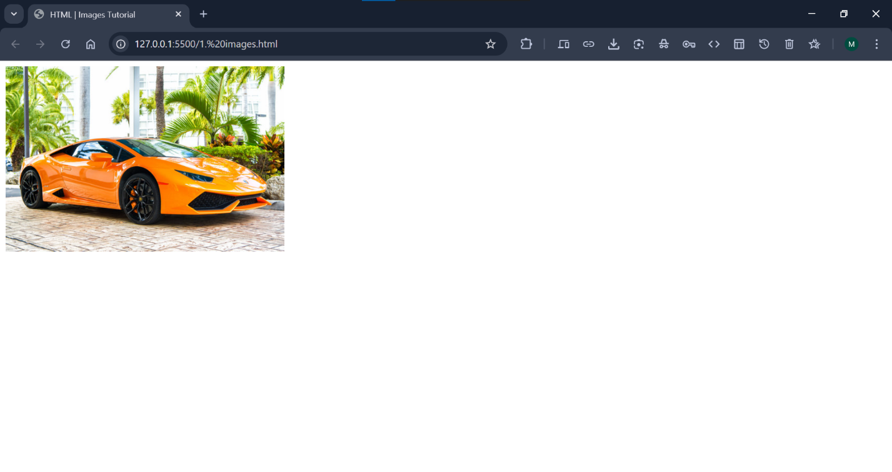

**Width and Height, or Style?**

The width, height, and style attributes are all valid in HTML.

However, we suggest using the style attribute. It prevents styles sheets from changing the size of images:

**Code:**

In the following example, we use internal CSS to define the size of all images as well as we use height and width attribute in img tag and also we use style attribute as an inline CSS.

The result is that if we use style attribute as an inline CSS ,so it prevents styles sheets from changing the size of images:

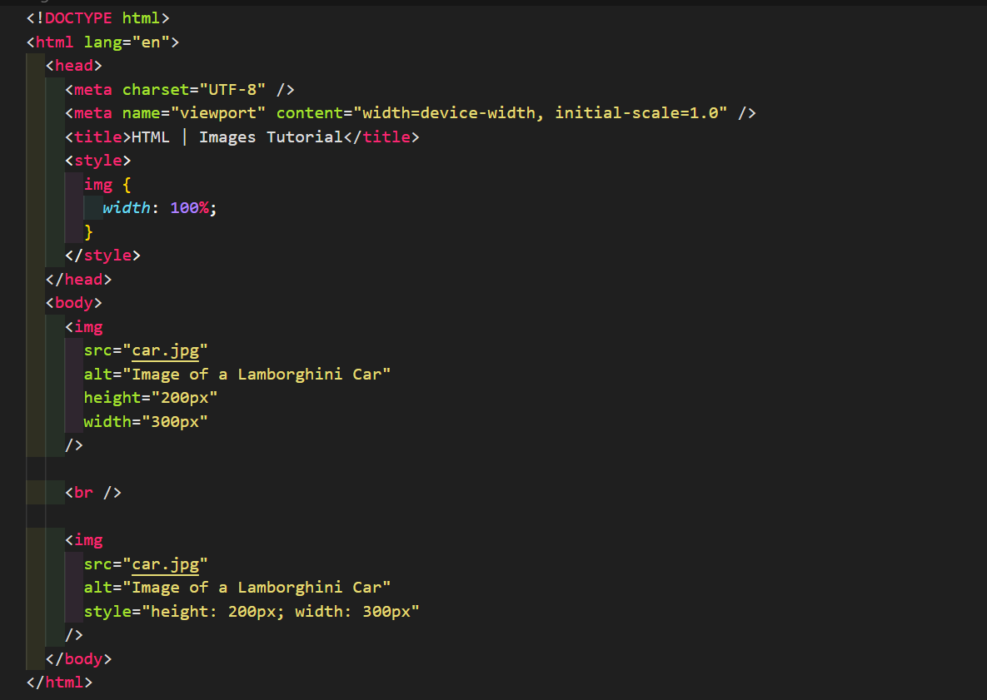

**Output:**

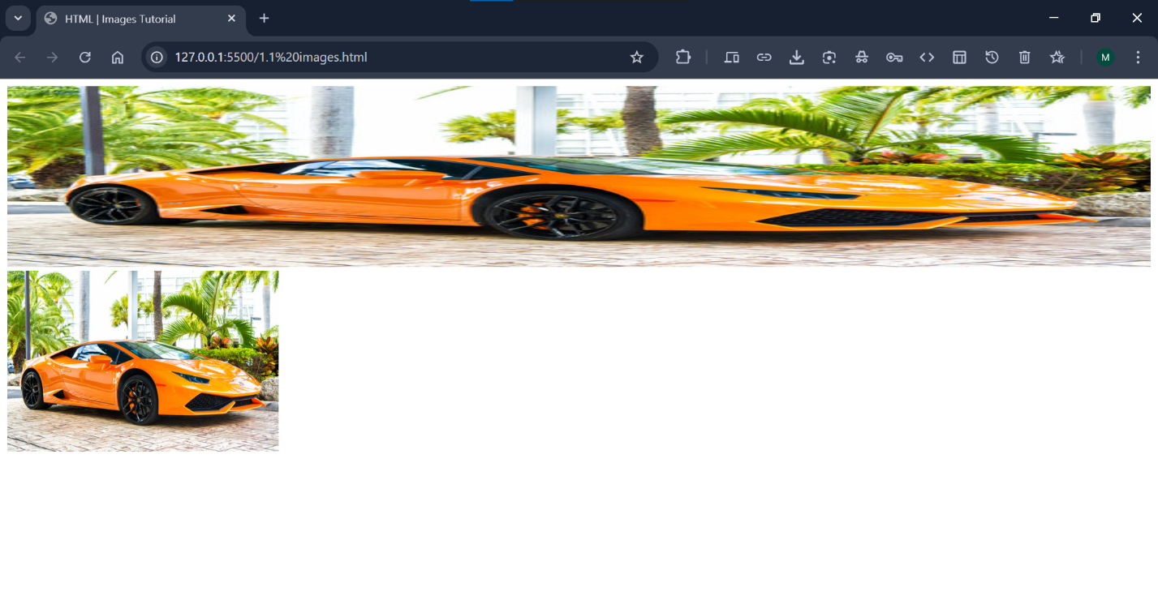

**Images in Sub-Folder:**

If you have your images in a sub-folder, you must include the folder name in the src attribute and you need to give the correct Relative URL of the image:

**Code:**



**Output:**

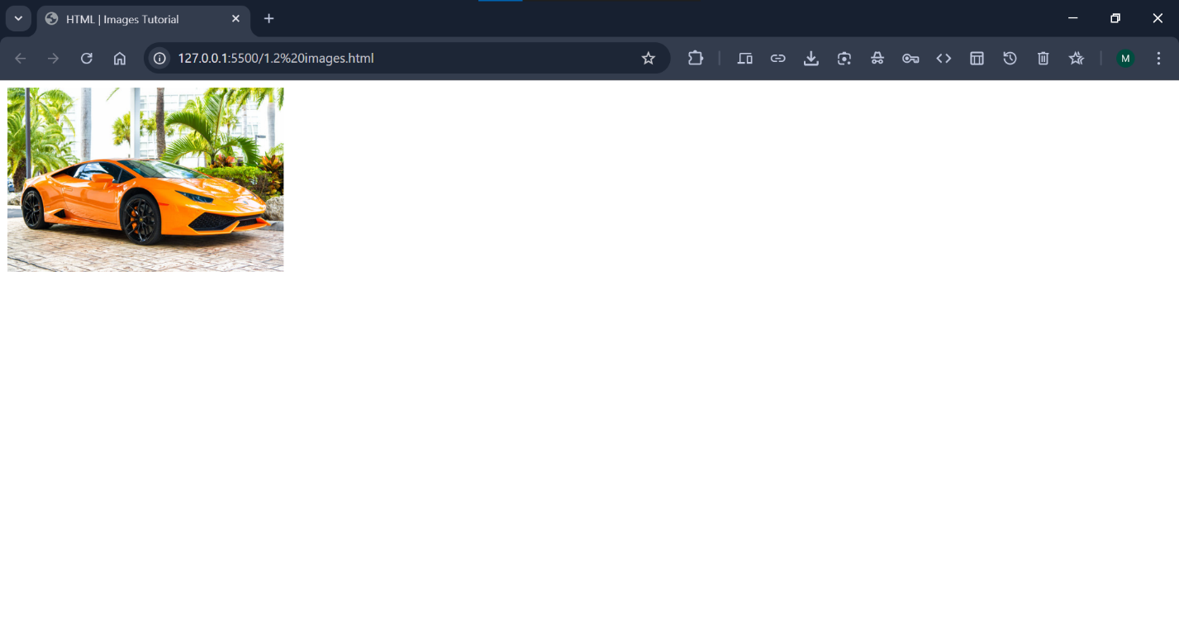

**Images on Another Server/Website:**

Some web sites point to an image on another server.

To point to an image on another server, you must specify an Absolute URL (full address) in the src attribute:

**Code:**

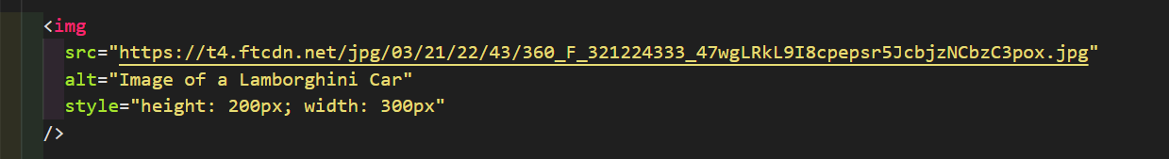

**Output:**

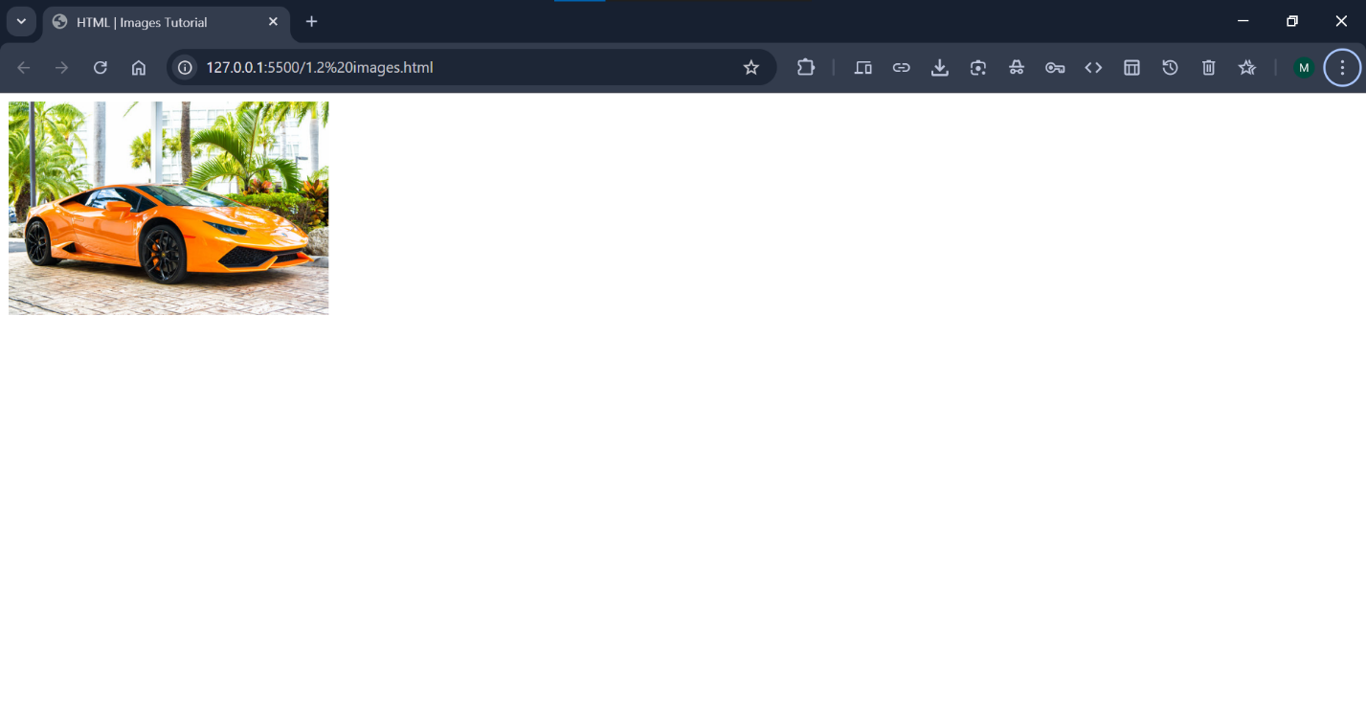

***Notes on External Images:*** External images might be under copyright. If you do not get permission to use it, you may be in violation of copyright laws. In addition, you cannot control external images; they can suddenly be removed or changed.

**Animated Images:**

HTML allows animated GIFs as an image:

**Code:**



**Output:**

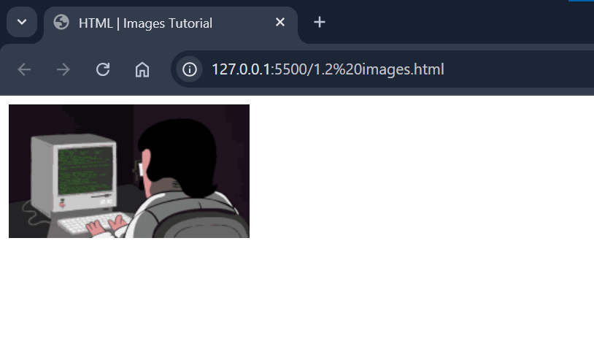

**Use Image as a Link:**

We can also use image as a link in HTML.

To use an image as a link, put the <img> tag inside the <a> tag:

**Code:**

***we can use image as a link:***

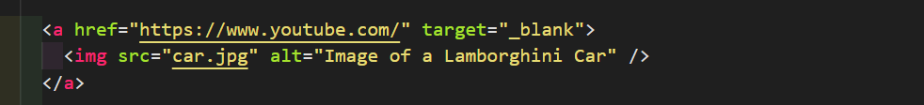

**Output:**

***When we click on this image, YouTube will open:***

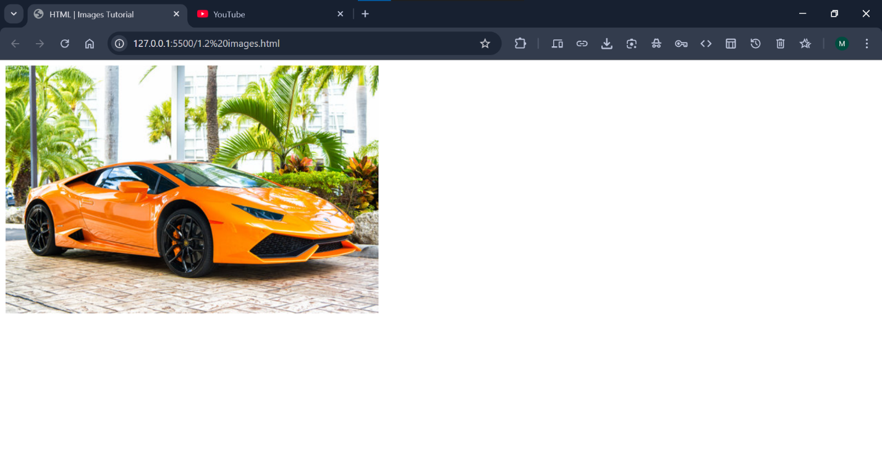

**Image Floating:**

The CSS float property defines the image float to the right or to the left of a text or paragraph:

**Syntax:**



**Values of Float Property:**

There are some values of float property:

1. Left
2. Right
3. None
4. Inline-end
5. Inline-start

**Code:**

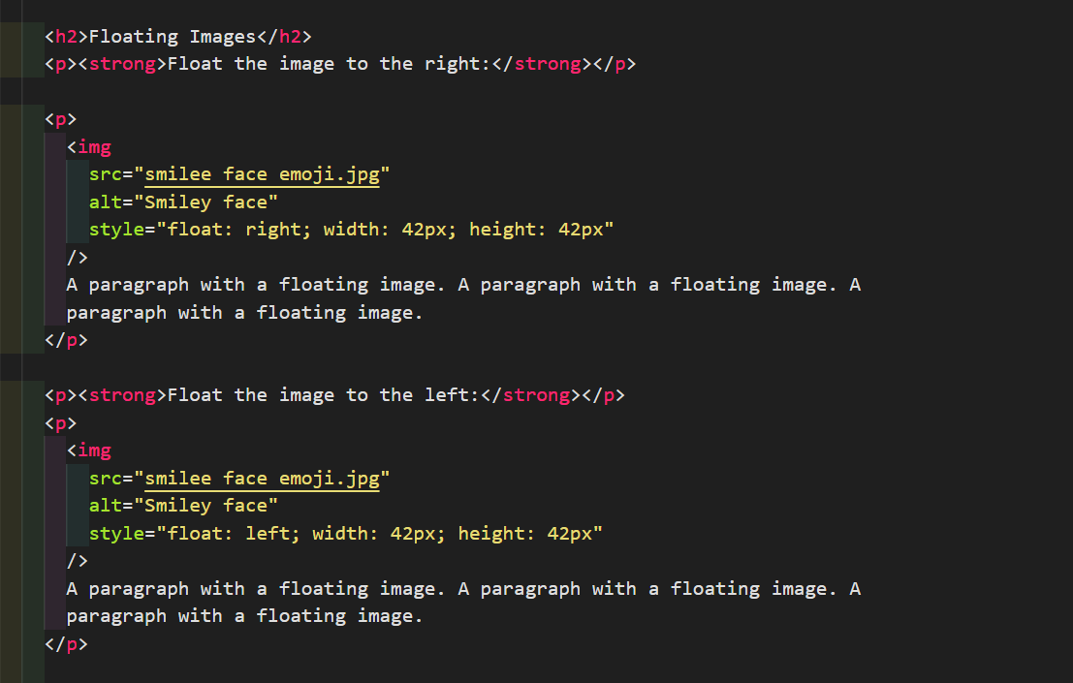

**Output:**

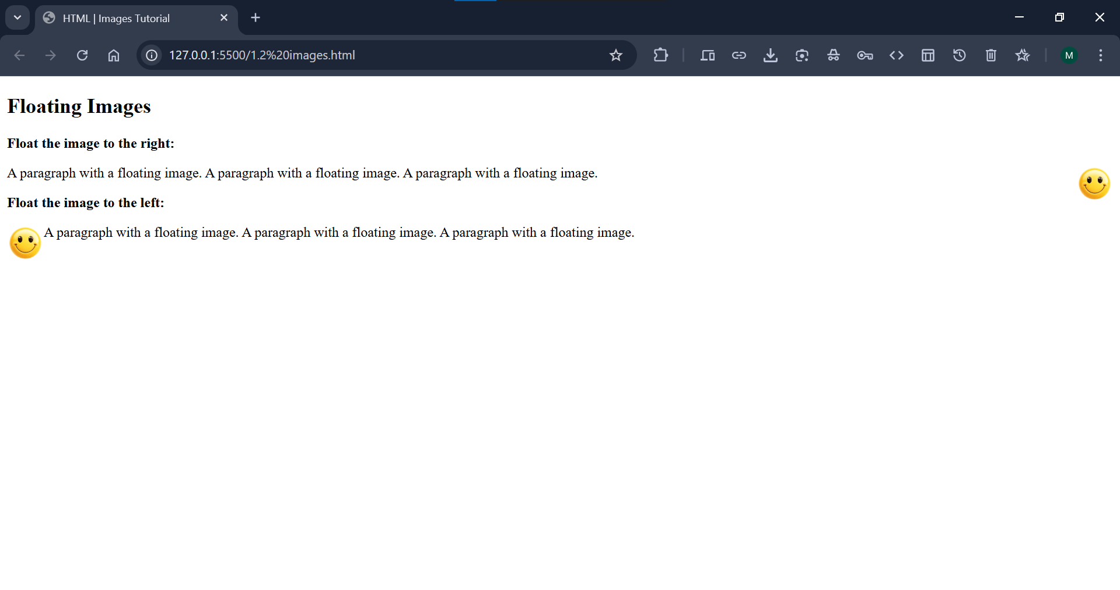

***Tip:*** To learn more about CSS Float, read our CSS Float Tutorial.

<https://www.w3schools.com/css/css_float.asp>

**Common Image Formats:**

Here are the most common image file types, which are supported in all browsers (Chrome, Edge, Firefox, Safari, Opera):

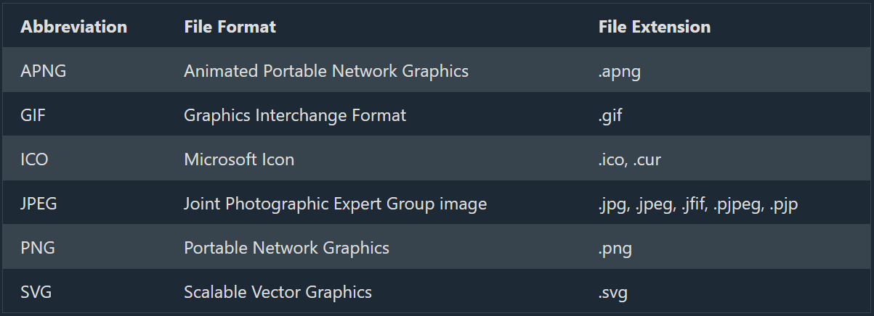

**Chapter Summary:**

1. Use the HTML <img> element to define an image
2. Use the HTML src attribute to define the URL of the image
3. Use the HTML alt attribute to define an alternate text for an image, if it cannot be displayed
4. Use the HTML width and height attributes or the CSS width and height properties to define the size of the image
5. Use the CSS float property to let the image float to the left or to the right

**HTML Image Tag:**

